In preparation for your initial health and fitness measurements being taken it would be beneficial if you could follow the guidelines below. Doing so will help to ensure that the assessment of your body composition is as accurate as possible.

- Wear comfortable, loose fitting clothing

- Drink plenty of fluids in the 24 hours before the test to ensure that you are well hydrated.

- Try to get at least 6 to 8 hours sleep the night before.

- Abstain from eating or drinking from 4 hours before your assessment.

- Avoid moderate or vigorous physical activity from 12 hours before the assessment.

- Abstain from alcohol consumption from 48 hours before the assessment.

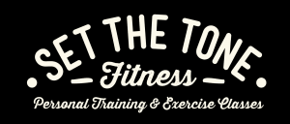
- Avoid diuretic agents (those that cause you to urinate, such as certain medications or caffeine) prior to the assessment, unless prescribed by a healthcare professional.

